# Lab: Linear Data Structures

This document defines the exercises for ["Java Advanced" course @ Software University](https://softuni.bg/courses/java-advanced). Please submit your solutions (source code) of all below described problems in [Judge](https://judge.softuni.bg/Contests/1021).

# Arrays and Lists

## Encrypt, Sort and Print Array

Write a program that reads a **sequence of strings** from the console. Encrypt every string by summing:

* The code of **each vowel multiplied by the string length**
* The code of **each consonant divided by the string length**

**Sort** the **number** sequence alphabetically and print it on the console.

On first line, you will always receive the number of strings you have to read.

### Examples

|  |  |  |
| --- | --- | --- |
| **Input** | **Output** | **Comments** |
| 4  Peter  Maria  Katya  Todor | 1032  1071  1168  1532 | Peter = 1071  Maria = 1532  Katya = 1032  Todor = 1168 |
| 3  Sofia  London  Washington | 1396  1601  3202 | Sofia = 1601  London = 1396  Washington = 3202 |

### Hints

* Thinks about the **Arrays** class
* You might help yourself with the **code** below:

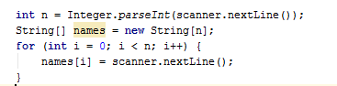

## Split by Word Casing

Read a **text**, split it into words and distribute them into **3 lists**.

* **Lower-case words** like “programming”, “at” and “databases” – consist of lowercase letters only.
* **Upper-case words** like “PHP”, “JS” and “SQL” – consist of uppercase letters only.
* **Mixed-case words** like “C#”, “SoftUni” and “Java” – all others.

Use the following **separators** between the words: , ; : . ! ( ) " ' \ / [ ] space

Print the 3 lists as shown in the example below.

### Examples

|  |  |
| --- | --- |
| **Input** | **Output** |
| Learn programming at SoftUni: Java, PHP, JS, HTML 5, CSS, Web, C#, SQL, databases, AJAX, etc. | Lower-case: programming, at, databases, etc  Mixed-case: Learn, SoftUni, Java, 5, Web, C#  Upper-case: PHP, JS, HTML, CSS, SQL, AJAX |

### Hints

* **Split** the input text using the above described **separators**.
* **Process** the obtained **list of words** one by one.
* Create 3 lists of words (initially empty): lowercase words, mixed-case words and uppercase words.
* Check each word and append it to one of the above 3 lists:
  + Count the **lowercase letters** and **uppercase letters**.
  + If all letters are **lowercase**, append the word to the lowercase list.
  + If all letters are **uppercase**, append the word to the uppercase list.
  + Otherwise the word is considered mixed-case 🡪 append it to the mixed-case list.
* Print the obtained 3 lists as shown in the example above.

# Multidimensional Arrays

## Sum Matrix Elements

Write a program that **reads a matrix** from the console and prints:

* The count of **rows**
* The count of **columns**
* The sum of all **matrix’s elements**

On the first line you will get the dimensions of the matrix in format **{rows, columns}.** On the next lines you will get the elements for each **row** separated with a coma.

### Examples

|  |  |
| --- | --- |
| **Input** | **Output** |
| 3, 6  7, 1, 3, 3, 2, 1 1, 3, 9, 8, 5, 6 4, 6, 7, 9, 1, 0 | 3  6  76 |

### Hints

* Help yourself with the code below for reading the matrix
* Try to use a **foreach**-loop

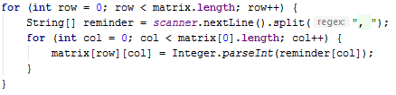

## Maximum Sum of 2x2 Submatrix

Write a program that **reads a matrix** from the console. Then find the biggest sum of a **2x2 submatrix.** Print the submatrix and its sum.

On the first line you will get the dimensions of the matrix in format **{rows, columns}.** On the next lines you will get the elements for each **row** separated with a coma.

### Examples

|  |  |
| --- | --- |
| **Input** | **Output** |
| 3, 6  7, 1, 3, 3, 2, 1 1, 3, 9, 8, 5, 6 4, 6, 7, 9, 1, 0 | 9 8  7 9  33 |
| 2, 4  10, 11, 12, 13  14, 15, 16, 17 | 12 13  16 17  58 |

### Hints

* Ensure that your program doesn’t throw an **IndexOutOfBoundsException()**

# Working with Stacks

## Simple Calculator

**Create a simple calculator** that can **evaluate simple expressions** that will not hold any operator different from addition and subtraction. There will not be parentheses or operator precedence.

Solve the problem **using a Stack**.

### Examples

|  |  |
| --- | --- |
| **Input** | **Output** |
| 2 + 5 + 10 - 2 - 1 | 14 |
| 2 - 2 + 5 | 5 |

### Hints

* Use an **ArrayDeque<>**
* Consider using the **add()** method
* You can either
  + add the elements and then pop them out
  + or push them and reverse the stack

## Decimal to Binary Converter

Create a simple program that **can convert a decimal number to its binary representation**. Implement an elegant solution **using a Stack**.

**Print the binary representation** back at the terminal.

### Examples

|  |  |
| --- | --- |
| **Input** | **Output** |
| 10 | 1010 |
| 1024 | 10000000000 |

### Hints

* If the given number is 0, just print 0
* Else, while the number is greater than zero, divide it by 2 and push the reminder into the stack

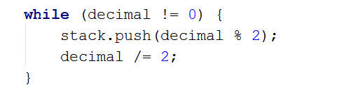

* When you are done dividing, pop all reminders from the stack, that is the binary representation

1. **Matching Brackets**

We are given an arithmetical expression with brackets. Scan through the string and extract each sub-expression.

Print the result back at the terminal.

**Examples**

|  |  |
| --- | --- |
| **Input** | **Output** |
| 1 + (2 - (2 + 3) * 4 / (3 + 1)) * 5 | (2 + 3)  (3 + 1)  (2 - (2 + 3) * 4 / (3 + 1)) |
| (2 + 3) - (2 + 3) | (2 + 3)  (2 + 3) |

**Hints**

* Use a stack, namely an **ArrayDeque()**
* Scan through the expression searching for brackets
  + If you find an opening bracket, push the index into the stack
  + If you find a closing bracket pop the topmost element from the stack. This is the index of the opening bracket.
  + Use the current and the popped index to extract the sub-expression

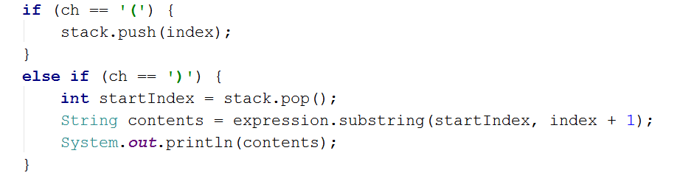

1. **Working with Queues**
2. **Hot Potato**

Hot potato is a game in which **children form a circle and start passing a hot potato**. The counting starts with the fist kid. **Every nth toss the child left with the potato leaves the game**. When a kid leaves the game, it passes the potato forward. This continues repeating **until there is only one kid left**.

Create a program that simulates the game of Hot Potato. **Print every kid that is removed from the circle**. In the end, **print the kid that is left last**.

**Examples**

|  |  |
| --- | --- |
| **Input** | **Output** |
| Mimi Pepi Toshko  2 | Removed Pepi  Removed Mimi  Last is Toshko |
| Gosho Pesho Misho Stefan Krasi  10 | Removed Krasi  Removed Pesho  Removed Misho  Removed Gosho  Last is Stefan |
| Gosho Pesho Misho Stefan Krasi  1 | Removed Gosho  Removed Pesho  Removed Misho  Removed Stefan  Last is Krasi |

1. **Math Potato**

Rework the previous problem so that a **child is removed only on a prime cycle** (cycles start from 1)

If a **cycle is not prime**, just **print the child's name.**

As before, print the name of the child that is left last.

**Examples**

|  |  |
| --- | --- |
| **Input** | **Output** |
| Mimi Pepi Toshko  2 | Removed Pepi  Prime Mimi  Prime Toshko  Removed Mimi  Last is Toshko |
| Gosho Pesho Misho Stefan Krasi  10 | Removed Krasi  Prime Pesho  Prime Misho  Removed Stefan  Prime Gosho  Removed Gosho  Prime Misho  Removed Pesho  Last is Misho |